Solution to every third end-of-chapter problem
Basics of Engineering Economy, 2nd edition
Leland Blank and Anthony Tarquin

Chapter 5
Annual Worth Analysis

5.1 AW = -7,000,000(A/P,15%,3) - 860,000
= -7,000,000(0.43798) - 860,000
= $-3,925,860

Therefore, required revenue is $3,925,860 per year

5.4 In $ millions,

AW = [-13 - 10(P/F,15%,1)](A/P,15%,10) – 1.2
= [-13 - 10(0.8696)](0.19925) – 1.2
= $-5.5229

Revenue required is $5,522,900 per year

5.7 First find PW, then annualize over three years

PW = -150,000[(400)(P/F,6%,1) + 300(P/F,6%,2) + 600(P/F,6%,3)]
= -60,000,000(0.9434) - 45,000,000(0.8900) - 90,000,000(0.8396)
= $-172,218,000

AW = -172,218,000(A/P,6%,3)
= -172,218,000(0.37411)
= $-64,428,476

5.10 (a) Use Equation [5.3] for CR per year.
CR = -3,800,000(A/P,12%,12) + 250,000(A/F,12%,12)
= -3,800,000(0.16144) + 250,000(0.04144)
= $-603,112

(b) AW = CR + A of AOC
= -603,112 – 350,000 – 25,000(A/G,12%,12)
= -603,112 – 350,000 - 25,000(4.1897)
= $-1,057,855

(c) One way to use a spreadsheet follows:
CR: single cell entry = -PMT(12%,12,-3800000,250000)
AW: Enter increasing gradient into B3:B14 and combine PMT functions
= -PMT(12%,12,-3800000,250000) - PMT(12%,12,NPV(12%,B3:B14))

5.13 (a) AW_{plastic} = -0.90(110)(43,560)(A/P,8%,20)
= -4,312,440(0.10185)
= $-439,222

AW_{rubber} = -2.20(110)(43,560)(A/P,8%,30)
= -10,541,520(0.08883)
= $-936,403

Select the plastic liner

(b) Plastic: liner cost; 0.9(110)43560) = $4,312,440
Function: -PMT(8,20,0,-4312440) Display: AW = $-439,232

Rubber liner cost; 2.20(110)43560) = $10,541,520
Function: -PMT(8,30,0,-10541520) Display: AW = $-936,376

Select the plastic liner

5.16 Tabulated factor solution:

(a) Monetary terms in $ million. From AW, project clearly makes 10% per year.

AW = -170(A/P,10%,20) + 85(1-0.225)
= -170(0.11746) + 65.875
= $+45.90 ($+45.9 million)

(b) AW goes negative between 30% and 40% per year.

@ 20%: AW = -170(A/P,20%,20) + 65.875 = $+30.96 million
@ 30%: AW = -170(A/P,30%,20) + 65.875 = $+14.60 million
@ 40%: AW = -170(A/P,40%,20) + 65.875 = $-2.21 million

Spreadsheet solution with x-y scatter chart:

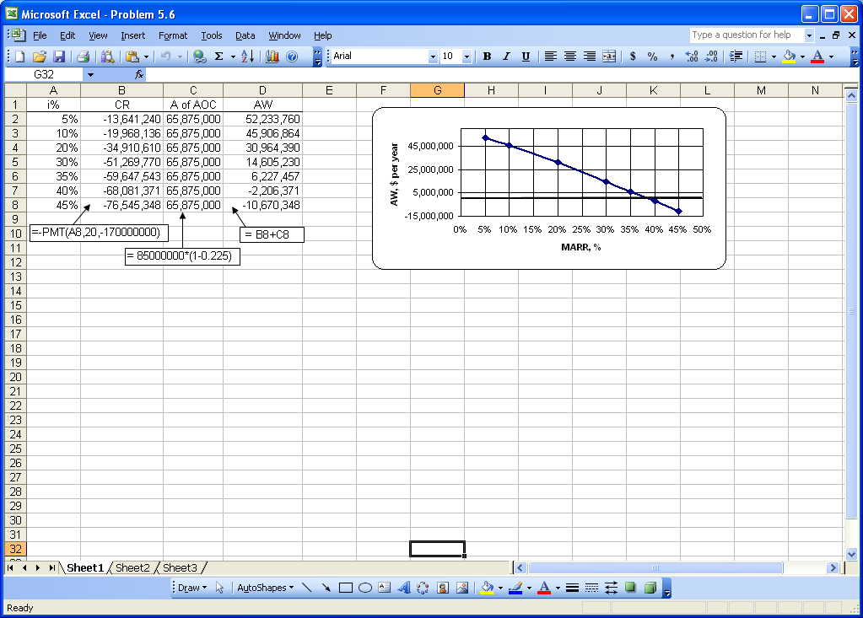

5.19 (a) AW evaluation indicates chamber 490G to be more economic.

AW_{D103} = -400,000(A/P,10%,3) + 40,000(A/F,10%,3) – 4000
= -400,000(0.40211) + 40,000(0.30211) – 4000
= $-152,760

AW_{490G} = -250,000(A/P,10%,2) + 25,000(A/F,10%,2) – 3000
= -250,000(0.57619) + 25,000(0.47619) – 3000
= $-135,143

(b) At P = $-300,000 and S = $30,000:
AW_{D103} = -300,000(A/P,10%,3) + 30,000(A/F,10%,3) – 4000
= -300,000(0.40211) + 30,000(0.30211) – 4000
= $-115,570

At P = $-500,000 and S = $50,000:
AW_{D103} = -500,000(A/P,10%,3) + 50,000(A/F,10%,3) – 4000
= -500,000(0.40211) + 50,000(0.30211) – 4000
= $-189,950
Cheaper model, P = $-300,000 will change the decision to D103.

(c) By spreadsheet for part (b) use the PMT functions at different P values.
490G: = -PMT(10%,2,-250000,25000)-3000
Display: $-135,143

D103 @ P=-300,000: = -PMT(10%,3,-300000,30000)-4000
Display: $-115,571

D103 @ P=-500,000: = -PMT(10%,3,-500000,50000)-4000
Display: $-189,952

5.22 AW = PW(i)

AW = [5,000,000 + 2,000,000(P/F,10%,10) + 100,000/(0.10)(P/F,10%,10)](0.10)
= [5,000,000 + 2,000,000(0.3855) + 1,000,000(0.3855)](0.10)
= $615,650

5.25 (a) Determine amount needed at end of year 20, followed by A to accumulate
this future amount.

CC = P = A/i = 24,000/0.08 = $300,000

F = A(F/A,8%,20)
300,000 = A(45.7620)
A = $6556 per year

By spreadsheet, enter = -PMT(8%,20,,300000) to display $6556.

(b) P = 24,000(P/A,8%,30)
= 24,000(11.2578)
= $270,187

270,187 = A(F/A,8%,20)
= A(45.7620)
A = $5904 per year

By spreadsheet, enter two functions.
P after 20 years: = -PV(8%,30,24000) Display: $270,187
A over 20 years: = -PMT(8%,20,,270187) Display: $5904

(c) For 30 year payout, difference = 6556 – 5904
= $652 per year less

5.28 Factors: Perpetual AW is equal to AW over one life cycle.

AW = {[-150,000(P/A,10%,4) - 25,000(P/G,10%,4)](P/F,10%,2)
- [225,000(P/A,10%,4)(P/F,10%,6)]}(A/P,10%,10)
= {[-150,000(3.1699) – 25,000(4.3781)](0.8264)
-[225,000(3.1699)(0.5645)]}(0.16275)
= $-144,198

Spreadsheet

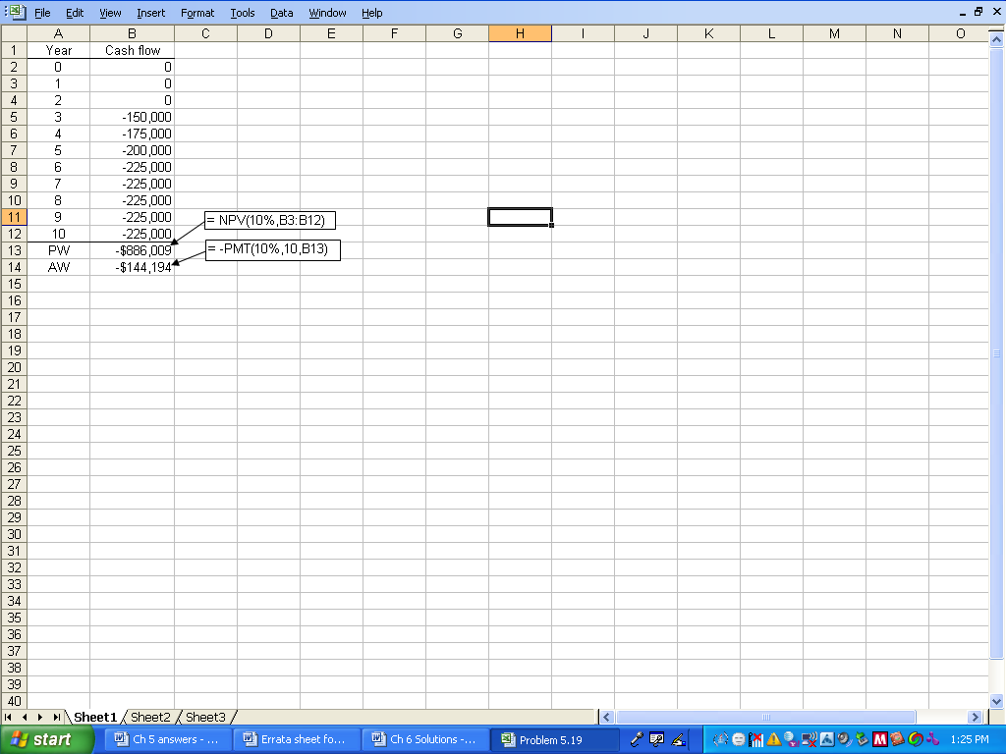

5.31 In $ million units. Effective annual i = (1.025)⁴ – 1 = 10.381%.

AW_{A} = -10(A/P,10.381%,5) + 0.7(A/F,10.381%,5) – 1.8
= -10(0.26637) + 0.7(0.16256) – 1.8
= $-4.35 ($-4.35 million)

AW_{B} = -35(0.10381) – 0.6
= $-4.23 ($-4.233 million)

Select B

5.34 Answer is (b)

5.37 Answer is (d)

5.40 Perpetual AW_{A} = -50,000(A/P,10%,3) – 20,000 + 10,000(A/F,10%,3)
= -50,000(0.40211) – 20,000 + 10,000(0.30211)
= $-37,084

AW is same for all years, including an infinite life.

Answer is (d)

